Faculty of AI Engineering

Department of AI &Data Science

Stroke prediction using Multi-Modeling
A senior 2 project report - submitted to complete the requirements for obtaining the Bachelor

Prepared by
Safa Bayazid
Rasha Alajjan

Supervised by
DR. MAISSA ABOUKASSEM

2025-2026


Faculty of Engineering
Department of AI&Data Science

SUPERVISOR CERTIFICATION
I certify that the preparation of this project Stroke Prediction Using Multi-Modeling
prepared by Safa Bayazid & Rasha Alajjan
Was made under my supervision at the Faculty of Engineering in partial fulfillment of the Requirements for the Degree of Bachelor

Name:

Date:

Signature:

Acknowledgments
﷽

إلى عميد الكلية الدكتور مهيب النيقري
إلى من كان لحرصه الدائم على تقدم الكلية ورفع مستوى العملية التعليمية أثر بالغ في تهيئة بيئة محفزة للعلم والابتكار،
إلى من سعى دومًا لتوفير الدعم والتوجيه لكل طالب ، ولم يبخل بوقته وخبرته في سبيل النهوض بالمستوى الأكاديمي،
أتقدم بخالص الشكر والامتنان على كل ما قدمتموه من تشجيع وإشراف معنوي، وعلى رؤيتكم الحكيمة التي كانت مصدر إلهام لنا
لكم كل التقدير والاحترام.

إلى من كان لتوجيهها العلمي الأثر الأكبر في إنجاز هذا العمل الدكتورة ميساء أبو القاسم
تقديرًا لجهودكِ الكريمة، وتوجيهاتكِ القيّمة، ودعمكِ المستمر الذي كان له الأثر الكبير في إنجاز هذا العمل.
كل الشكر والامتنان لما قدمتِه من علم وخبرة وصبر.
جزاكِ الله عنا كل خير.

إلى المهندس أنس عبد العزيز
إلى من كان لطيفاً وكريماً معنا، وقدم لنا المساعدة والنصيحة عندما احتجنا إليها،
شكرًا لكل لحظة خصصها لنا، ولكل كلمة شجعتنا وأعطتنا دفعة للاستمرار،
لكم كل التقدير والامتنان على لطفكم وروحكم الجميلة.

Dedication

Abstract
Stroke is one of the leading causes of mortality and long-term disability worldwide, making early risk identification essential for effective prevention and intervention. Traditional clinical risk assessment methods often rely on linear assumptions and limited feature interactions, which may reduce predictive accuracy in complex medical datasets. This project investigates the application of machine learning techniques for predicting stroke risk using a structured clinical dataset containing demographic, physiological, and lifestyle-related features.
This report presents an explainable artificial intelligence (XAI) system for stroke risk prediction that integrates structured clinical data and medical image analysis within a unified deployment framework. The proposed system combines a CatBoost-based machine learning model for tabular patient data with a Vision Transformer (ViT) deep learning model for image-based classification ,using Streamlit and incorporates Grad-CAM-based visual explanations to enhance interpretability. The system is deployed as an interactive bilingual web application using Streamlit .Experimental results demonstrate the system’s effectiveness in probability-based stroke risk estimation while maintaining transparency and usability for clinical decision support.

الملخص
تُعد السكتة الدماغية أحد الأسباب الرئيسية للوفاة والإعاقة طويلة الأمد في جميع أنحاء العالم، مما يجعل التحديد المبكر للمخاطر أمراً ضرورياً للوقاية والتدخل الفعالين. غالباً ما تعتمد طرق تقييم المخاطر السريرية التقليدية على افتراضات خطية وتفاعلات محدودة بين العوامل، وهو ما قد يقلل من دقة التنبؤ في المجموعات المعقدة للبيانات الطبية. يبحث هذا المشروع في تطبيق تقنيات تعلم الآلة للتنبؤ بخطر الإصابة بالسكتة الدماغية باستخدام مجموعة بيانات سريرية منظمة تحتوي على ميزات ديموغرافية، وفسيولوجية، وأخرى متعلقة بنمط الحياة.
​تقدم هذه الورقة نظامًا قائمًا على الذكاء الاصطناعي القابل للتفسير (XAI) لتوقّع خطر الإصابة بالسكتة الدماغية، حيث يدمج بين البيانات السريرية المنظمة وتحليل الصور الطبية ضمن إطار نشر موحّد.
يجمع النظام المقترح بين نموذج تعلم آلي معتمد على خوارزمية CatBoost لمعالجة بيانات المرضى الجدولية، ونموذج تعلم عميق قائم على المحوّل البصري (Vision Transformer – ViT) لتصنيف الصور الطبية. كما يتضمن تفسيرات بصرية معتمدة على تقنية Grad-CAM لتعزيز قابلية تفسير النتائج.
وقد تم نشر النظام على شكل تطبيق ويب تفاعلي ثنائي اللغة باستخدام منصة Streamlit،
وتُظهر النتائج التجريبية فاعلية النظام في تقدير خطر السكتة الدماغية اعتمادًا على الاحتمالات، مع الحفاظ على مستوى عالٍ من الشفافية وسهولة الاستخدام لدعم اتخاذ القرار السريري.

Table of Contents:
Table of Contents: VII
Chapter 1 Introduction 1
1Introduction 2
Background and Medical Definition of Stroke 2
1.2 Global Epidemiology and Societal Impact 2
1.3 Clinical Risk Factors for Stroke 3
1.4 Motivation for Stroke Risk Prediction 4
1.5 Role of Machine Learning in Medical Risk Prediction 4
1.6 Objectives and Contributions of This Study 5
Chapter 2 Studies Related to the Project 6
Study 1 7
Title: Automated Ischemic Stroke Classification from MRI Scans: Using a Vision Transformer Approach 7
a) Study Objective and Contributions 7
b) Similarities with Our Project 7
c) Differences from Our Project 8
d) Relevance to Our Project 8
Study 2 9
Title: Brain Stroke Classification Using CT Scans with Transformer-Based Models and Explainable AI 9
a) Study Objective and Contributions 9
b) Similarities with Our Project 9
c) Differences from Our Project 10
d) Relevance to Our Project 10
Study 3 11
Title: Hu Moments and Transformers: A Breakthrough in Feature Extraction and Classification for Detecting Intracranial Hemorrhages in CT Scans 11
a) Study Objective and Contributions 11
b) Similarities with Our Project 11
c) Differences from Our Project 12
d) Relevance to Our Project 12
Study 4 13
Title: Predicting Stroke Outcome: A Case for Multimodal Deep Learning Methods with Tabular and CT Perfusion Data 13
a) Study Objective and Contributions 13
b) Similarities with Our Project 13
c) Differences from Our Project 13
d) Relevance to Our Project 14
Study 5 14
Title: An Explainable AI Framework for Stroke Classification Based on CT Brain Images 14
a) Study Objective and Contributions 14
b) Similarities with Our Project 14
c) Differences from Our Project 14
d) Relevance to Our Project 14
Study 6 15
Title: An Effective Brain Stroke Diagnosis Strategy Based on Feature Extraction and Hybrid Classifier 15
a) Study Objective and Contributions 15
b) Similarities with Our Project 15
c) Differences from Our Project 15
d) Relevance to Our Project 15
Comparative Summary of Related Work and Proposed Project 16
Chapter 3 DATASET DESCRIPTION AND ANALYSIS 17
3.1 Dataset Overview and Origin 18
3.2 Dataset Structure and Attributes 18
3.3 Medical Interpretation of Dataset Features 19
3.3.1 Demographic Features 19
3.3.2 Clinical and Physiological Features 20
3.3.3 Lifestyle-Related Features 21
3.3.4 Socioeconomic and Environmental Features 22
3.4 Target Variable and Problem Formulation 22
3.5 Class Imbalance Analysis 23
3.6 Missing Values and Data Quality 24
3.7 Ethical Considerations in Medical Data Usage 25
Chapter 4 Implementation 26
4.1 Introduction 27
4.2 System Architecture Overview 27
4.3 Train–Test Split and Experimental Setup 28
4.4 Model Selection: 29
CatBoostClassifier 29
5. Image-Based Stroke Risk Classification 29
Deployment Using Streamlit and Application Design 31
Chapter 5 Result 37
5.1 Evaluation Metrics for Imbalanced Medical Data 38
5.2 Confusion Matrix Interpretation in Clinical Context 39
5.3 Logistic Regression Results 41
5.4 Limitations of Results 44
Chapter 6 Conclusion 45
6.1 Conclusion 46
6.2 Study Limitations 47
6.3 Ethical Considerations 48
6.4 Future Work 49
References 50

Table of Figures
Figure 1.Missing Value 24
Figure 2.Dataset image 26
Figure 3. Dataset RAW 27
Figure 4.BLUR BEFOR 28
Figure5. Dataset AUG 30
Figure 6.BLUR AFTER 30
Figure 7. Dataset ALL RAW-AUG 30
Figure 8.Spliting Data 34
Figure 9.Heat Map 36
Figure 10.Application Interface 41
Figure 11..Application Interface 42
Figure 12..Application Interface 42
Figure 13.Confusion Matrix 46
Figure 14.Compare Result CM 46
Figure 15.Performance Comparison 46
Figure 16.Ensemble Vit loss Plot 46
Figure 17.Ensemeble ConnVeXt Loss plot 46
Figure 18.Ensameble Swin Loss 50
Figure 19.interface image 50
Figure 20.interface image result 50
Figure 21.Performance Comparison 52
Figure 22.Compare Result CM 54
Figure 23.ROC plot 54
Figure 24. .precision_Recall plot 55
Figure 25.Analyze Risk text 55
Figure 26. Analyze Risk text result 56
Figure 27. Analyze Risk text 56
Figure 28. Analyze Risk text result 57

Table of Shortcuts:
AI | Artificial inelegant
BMI | Body Mass Index
DALYs | Disability-Adjusted Life Years
FN | False Negative
FP | False Positive
KNN | K-Nearest Neighbors
LR | Logistic Regression
ML | Machine Learning
WHO | World Health Organization
TN | True Negative
TP | True Positive
RF | Random Forest

Tables of tables
Table 1.Comapre Papres 16
Table 2.CSV dataset 19
Table 3.Result Comparation ct 39
Table 4. Result Comparation Tabluer 39

Chapter 1 Introduction

1Introduction
In this chapter, we will introduce our project, and discuss the main issues and reasons for building this model. We will also explain the objectives and goals we aim to accomplish with this. Finally, we will provide an overview of the main concepts and tools used and required in this model.

Background and Medical Definition of Stroke
Stroke is a serious medical condition characterized by the sudden interruption of blood supply to the brain, leading to neuronal damage, disability, or death. Clinically, stroke is defined as a rapid onset of focal or global neurological deficit lasting more than 24 hours or leading to death, with vascular causes as the primary etiology. The interruption of cerebral blood flow deprives brain tissue of oxygen and glucose, resulting in irreversible neuronal injury within minutes if untreated.
There are two primary categories of stroke. Ischemic stroke, which accounts for approximately 85% of all cases, occurs due to arterial occlusion caused by thrombosis or embolism. Hemorrhagic stroke results from the rupture of cerebral blood vessels, leading to intracerebral or subarachnoid hemorrhage. Although hemorrhagic strokes are less common, they are associated with higher mortality rates.
Stroke is not only an acute medical emergency but also a chronic public health burden. Survivors frequently experience long-term complications, including motor impairment, speech disorders, cognitive decline, and emotional disturbances. These outcomes significantly reduce quality of life and place substantial pressure on healthcare systems worldwide.

1.2 Global Epidemiology and Societal Impact
Stroke remains one of the leading causes of mortality and long-term disability globally. According to reports from the World Health Organization, stroke is the second leading cause of death and a major contributor to disability-adjusted life years (DALYs). Each year, millions of individuals experience a first-time stroke, with a significant proportion occurring in low- and middle-income countries.
The economic impact of stroke is profound. Direct medical costs include emergency care, hospitalization, imaging, medication, and rehabilitation services. Indirect costs arise from productivity loss, long-term caregiving, and premature mortality. As global populations age and the prevalence of non-communicable diseases increases, the burden of stroke is expected to rise further.
These statistics highlight the urgent need for effective prevention strategies. While acute treatment options such as thrombolysis and mechanical thrombectomy have improved outcomes, they are time-sensitive and not universally accessible. Consequently, early identification of high-risk individuals remains one of the most effective strategies for reducing stroke incidence.

1.3 Clinical Risk Factors for Stroke
Stroke is a multifactorial disease influenced by a combination of modifiable and non-modifiable risk factors. Non-modifiable factors include age, sex, and genetic predisposition. The risk of stroke increases exponentially with age, and males generally exhibit higher incidence rates, although females experience greater lifetime risk due to longer life expectancy.
Modifiable risk factors play a critical role in stroke prevention. Hypertension is the most significant contributor, as chronic elevated blood pressure damages vascular endothelium and accelerates atherosclerosis. Diabetes mellitus increases stroke risk through metabolic dysregulation and vascular inflammation. Cardiovascular diseases such as atrial fibrillation promote embolic events, while lifestyle factors including smoking, physical inactivity, and obesity further compound risk.
Importantly, many of these risk factors coexist and interact in non-linear ways. Traditional clinical risk scoring systems often struggle to capture these complex interactions, leading to suboptimal predictive performance in diverse populations.

1.4 Motivation for Stroke Risk Prediction
Given the severe consequences of stroke and the availability of preventive interventions, accurate risk prediction is of paramount importance. Early identification of individuals at high risk allows for targeted interventions, including lifestyle modification, pharmacological treatment, and closer clinical monitoring.
Conventional statistical approaches and rule-based risk scores have been widely used in clinical practice. However, these methods typically rely on linear assumptions and limited feature interactions. As a result, their predictive capability may be insufficient when dealing with heterogeneous patient populations and complex medical data.
The increasing availability of electronic health records and population-level datasets provides an opportunity to move beyond traditional approaches. By leveraging historical patient data, predictive models can learn patterns that are difficult to identify through manual analysis.

1.5 Role of Machine Learning in Medical Risk Prediction
Machine Learning (ML) offers a powerful framework for modeling complex, high-dimensional data. Unlike traditional statistical models, ML algorithms can capture non-linear relationships, feature interactions, and subtle patterns without explicit programming. This makes ML particularly well-suited for medical risk prediction tasks, where disease etiology is often multifactorial and probabilistic.
In the context of stroke prediction, ML models can integrate demographic, clinical, and lifestyle variables to estimate individual risk. Algorithms such as logistic regression, k-nearest neighbors, and ensemble methods have been successfully applied in previous studies, demonstrating improved predictive performance compared to conventional techniques.
However, applying ML in healthcare also introduces challenges. Medical datasets are often imbalanced, with relatively few positive cases compared to negative ones. In stroke prediction, false negatives carry severe clinical consequences, as failing to identify a high-risk patient may lead to preventable morbidity or mortality. Therefore, model evaluation must go beyond simple accuracy and consider clinically meaningful metrics.

1.6 Objectives and Contributions of This Study
The primary objective of this project is to develop and evaluate machine learning models for predicting stroke risk using a structured clinical dataset. Specifically, this study aims to:
Perform comprehensive analysis and preprocessing of a real-world stroke risk dataset
Design and implement multiple machine learning models for stroke prediction
Evaluate model performance using appropriate metrics for imbalanced medical data
Interpret results from both statistical and clinical perspectives
This project contributes to undergraduate-level research by integrating medical knowledge, data analysis, and machine learning theory into a unified predictive framework. The findings aim to demonstrate how data-driven methods can support clinical decision-making while highlighting their limitations and ethical considerations.

Chapter 2 Studies Related to the Project

Study 1

Title:
Automated Ischemic Stroke Classification from MRI Scans: Using a Vision Transformer Approach
Authors: Wafae Abbaoui et al.
Year: 2024
Journal: Journal of Clinical Medicine

a) Study Objective and Contributions
This study proposes a Vision Transformer (ViT-B16) model for classifying brain MRI images (T2 FLAIR) into two categories: ischemic stroke and normal cases, using data collected from a Moroccan university hospital (UM6SS). The dataset was preprocessed and divided into training, validation, and test sets. Data pipelines were implemented using tf.data, along with extensive data augmentation techniques. The performance of ViT-B16 was compared with conventional CNN models such as VGG-16 and ResNet50. The ViT-B16 model achieved an accuracy of approximately 97.6%, significantly outperforming traditional CNN-based approaches on the same dataset.

b) Similarities with Our Project
- Utilization of Vision Transformer (ViT) models for analyzing medical brain images.
- Focus on ischemic stroke as a primary pathological condition.
- Adoption of systematic data splitting and augmentation strategies to enhance training.

c) Differences from Our Project
- The study uses MRI images, whereas our project primarily focuses on CT images.
- The task is limited to binary classification (stroke vs. normal), while our project additionally estimates stroke severity and lesion localization.
- No integration of clinical tabular data or multimodal learning is employed, unlike our proposed system.

d) Relevance to Our Project
- Confirms the effectiveness of ViT architectures over CNNs for stroke classification.
- Provides a reference pipeline for data preparation and augmentation applicable to CT images.
- Serves as scientific evidence supporting our choice of Transformer-based models.

Study 2

Title:
Brain Stroke Classification Using CT Scans with Transformer-Based Models and Explainable AI
Authors: S. Qari, M. A. Thafar
Year: 2025
Journal: Diagnostics

a) Study Objective and Contributions
This study addresses brain stroke classification using CT scans into three categories: ischemic stroke, hemorrhagic stroke, and normal cases. Advanced Transformer-based models such as MaxViT, ViT, TNT, and ConvNeXt were evaluated. Due to severe class imbalance, both traditional augmentation techniques and conditional GANs (cGANs) were employed to generate synthetic samples for minority classes. Transfer learning was applied, and Grad-CAM++ was used for model explainability. The MaxViT with cGAN augmentation achieved the best performance, with an accuracy of approximately 98%, high F1-score, and AUC ≈ 0.995.

b) Similarities with Our Project
- Use of CT brain images for stroke analysis.
- Employment of Transformer-based models outperforming CNNs.
- Handling data imbalance and integrating explainable AI techniques.

c) Differences from Our Project
- The task is limited to stroke type classification and does not address severity estimation or precise lesion localization.
- No clinical data or multimodal fusion is incorporated.
- The system focuses solely on classification without integration into a broader clinical decision support framework.

d) Relevance to Our Project
- Provides guidance for fine-tuning Transformer models such as ViT and MaxViT.
- Demonstrates the effectiveness of cGAN-based augmentation for imbalanced CT datasets.
- Supports the use of Grad-CAM++ for lesion visualization in CT images.

Study 3

Title:
Hu Moments and Transformers: A Breakthrough in Feature Extraction and Classification for Detecting Intracranial Hemorrhages in CT Scans
Authors: Huda Mirza Saifuddin et al.
Year: 2025
Journal: Multidisciplinary Science Journal

a) Study Objective and Contributions
This study proposes a framework for detecting intracranial hemorrhage (ICH) and classifying its subtypes using three approaches:
- Handcrafted feature extraction using Hu Moments with a Random Forest classifier,
- Swin Transformer,
- Vision Transformer (ViT).
The study utilizes the large-scale RSNA CT dataset and performs multi-label classification of hemorrhage subtypes (EDH, IPH, IVH, SAH, SDH). The Hu+RF approach achieved an accuracy of approximately 82.6%, while Swin and ViT models exceeded 99% accuracy, demonstrating the superiority of Transformer-based models.

b) Similarities with Our Project
- Focus on CT brain imaging for stroke and hemorrhage analysis.
- Use of Vision and Swin Transformers in medical image classification.
- Consideration of multi-class classification tasks.

c) Differences from Our Project
- Focuses on hemorrhage detection rather than ischemic stroke severity.
- No clinical data or multimodal integration.
- Emphasis on feature extraction comparison rather than clinical system deployment.

d) Relevance to Our Project
- Strong evidence of Transformer superiority in CT-based brain diagnosis.
- Useful dataset preparation and evaluation methodology.
- Inspiration for future hybrid models combining handcrafted and deep features.

Study 4

Title:
Predicting Stroke Outcome: A Case for Multimodal Deep Learning Methods with Tabular and CT Perfusion Data
Authors: Balázs Borsos et al.
Year: 2024
Journal: Artificial Intelligence in Medicine

a) Study Objective and Contributions
This study predicts functional outcomes of ischemic stroke patients after three months using clinical tabular data and 3D CT perfusion (CTP) images. Models based on clinical data alone (Random Forest, Gradient Boosting, TabNet), image data alone (3D ResNet, MedicalNet), and multimodal fusion were compared. The proposed DAFT architecture dynamically integrates clinical features into CNN feature maps. DAFT achieved the best performance with AUC ≈ 0.75 and F1 ≈ 0.80.

b) Similarities with Our Project
- Multimodal fusion of clinical and imaging data.
- Focus on clinically meaningful outcomes.

c) Differences from Our Project
- Targets outcome prediction rather than stroke detection and severity estimation.
- Uses CT perfusion data instead of standard CT scans.
- Does not employ ViT or Swin Transformers.

d) Relevance to Our Project
- Provides a strong reference for multimodal fusion strategies.
- Reinforces the importance of combining clinical and imaging data.

Study 5

Title:
An Explainable AI Framework for Stroke Classification Based on CT Brain Images
Authors: S. Aksoy et al.
Year: 2025
Journal: AI (MDPI)

a) Study Objective and Contributions
This study introduces an explainable AI framework for classifying CT brain images into hemorrhagic stroke, ischemic stroke, and normal cases using ResNet-18 with transfer learning. Data imbalance was handled through augmentation and weighted loss, and XRAI was employed for visual explanation. The model achieved approximately 95% accuracy and a weighted F1-score of 0.95.

b) Similarities with Our Project
- CT-based stroke classification.
- Use of data augmentation and explainable AI.

c) Differences from Our Project
- Relies on CNNs rather than Transformers.
- Limited to classification without severity estimation or multimodal fusion.

d) Relevance to Our Project
- Serves as a baseline for CNN vs. Transformer comparison.
- Provides insights into explainable AI interface design.

Study 6

Title:
An Effective Brain Stroke Diagnosis Strategy Based on Feature Extraction and Hybrid Classifier
Authors: Maha Samir Elsayed et al.
Year: 2025
Journal: Scientific Reports

a) Study Objective and Contributions
This study proposes a hybrid stroke diagnosis strategy combining features extracted from VGG16 and Vision Transformer (ViT) models using CT images from Kaggle. A binary classification task (stroke vs. normal) was performed with extensive augmentation. The hybrid model achieved approximately 99.6% accuracy and F1 ≈ 0.99, with explanations provided via Grad-CAM and LIME.

b) Similarities with Our Project
- Use of ViT on CT images.
- Kaggle dataset usage.
- Integration of explainable AI.

c) Differences from Our Project
- Binary classification only.
- No clinical data or structured multimodal fusion.

d) Relevance to Our Project
- Strong numerical benchmark for ViT performance.
- Supports the adoption of Grad-CAM in the proposed system.

Comparative Summary of Related Work and Proposed Project
Table 1.Comapre Papres
Result | DataSet | Model | Classification | CSV files | Multi types data | سنة النشر | Studies
Accuracy ≈ 97.6٪ | MRI (T2 FLAIR) | ViT-b16 (VGG-16) | (Stroke / Normal) | NO | No | 2024 | Study 1
Accuracy ≈ 98٪, AUC ≈ 0.995 | CT (Axial) | MaxViT, ViT, TNT, ConvNeXt | (Ischemic / Hemorrhagic / Normal) | No | No | 2025 | Study 2
Swin/ViT Accuracy > 99٪ | CT (RSNA ICH) | Hu+RF, Swin, ViT | ICH (Multi-label) | NO | No | 2025 | Study 3
AUC ≈ 0.75, F1 ≈ 0.80 | CT Perfusion + CSV files | TabNet, 3D ResNet, DAFT Multimodal | (mRS Binary) | Yes | Yes (DAFT) | 2024 | Study 4
Accuracy ≈ 95٪, F1 ≈ 0.95 | CT | ResNet-18 + XRAI | (Hemorrhagic / Ischemic / Normal) | NO | NO | 2025 | Study 5
Accuracy ≈ 99.6٪, F1 ≈ 0.99 | CT (Kaggle) | Hybrid ViT + VGG16 | (Stroke / Normal) | NO | NO(Image only) | 2025 | Study 6
متوقع تحسين الدقة والتفسير مقارنة بـ CNN (≈ >96٪) | CT (Kaggle) +CSV files | ViT / Swin + TabNet/DNN Fusion | Predict the Strok and the amount of it and recognition the injure area | Yes | Yes(CSV file +  Images ) | 2025+ | Our Project

Chapter 3 DATASET DESCRIPTION AND ANALYSIS

3.1 Dataset Overview and Origin
The dataset utilized in this study is a structured stroke risk dataset comprising demographic, clinical, and lifestyle-related attributes associated with the occurrence of stroke. It consists of anonymized patient records and is designed to support predictive modeling of stroke risk based on established medical risk factors.
Each record in the dataset represents a single individual, with features describing personal demographics, underlying health conditions, and behavioral characteristics. The target variable is a binary indicator specifying whether the individual has previously experienced a stroke. Such datasets are typically derived from large-scale health surveys or electronic health record systems and are widely adopted in stroke prediction research due to their inclusion of clinically meaningful variables.
The dataset is tabular in nature, making it well suited for classical machine learning algorithms while still capturing a broad spectrum of stroke-related risk information. Prior to model development, comprehensive preprocessing and exploratory data analysis are essential to ensure data quality, enhance interpretability, and support ethical and responsible use of the data.

3.2 Dataset Structure and Attributes
The dataset comprises multiple input features and a single binary output variable. The target variable, stroke, denotes the occurrence of a stroke event and is encoded as a binary label, where 1 indicates the presence of stroke and 0 represents the absence of any reported stroke history.

The input features are organized into four main categories:
- Demographic attributes
- Clinical and physiological attributes
- Lifestyle-related attributes
- Socioeconomic indicators
This categorization mirrors standard clinical risk assessment practices, in which stroke risk is evaluated through a combination of patient demographics, medical history, physiological conditions, and lifestyle and socioeconomic factors. Such a structured feature grouping facilitates interpretability and supports clinically meaningful analysis in predictive modeling.

3.3 Medical Interpretation of Dataset Features
Table 2.CSV dataset
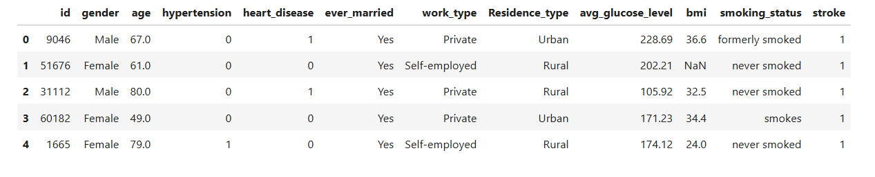

2.3.1 Demographic Features
Age
Age is one of the most influential non-modifiable risk factors for stroke. Stroke risk increases progressively with advancing age due to cumulative vascular damage, arterial stiffening, and the rising prevalence of comorbid conditions such as hypertension and diabetes mellitus. Representing age as a continuous numerical feature enables the model to capture gradual risk escalation rather than relying on predefined age thresholds, thereby preserving clinically meaningful risk gradients.
Gender
Biological sex plays a significant role in stroke risk through hormonal, genetic, and behavioral pathways. Although males generally exhibit a higher incidence of stroke at younger ages, females tend to experience greater stroke severity, poorer outcomes, and a higher lifetime risk, largely due to increased longevity. Consequently, gender is an important demographic predictor, even though its effect is often mediated by other clinical and lifestyle-related variables.

3.3.2 Clinical and Physiological Features
Hypertension
Hypertension is widely recognized as the most significant modifiable risk factor for stroke. Persistent elevation of blood pressure leads to vascular endothelial damage, accelerates atherosclerotic processes, and substantially increases the risk of both ischemic and hemorrhagic stroke. In the dataset, hypertension is encoded as a binary variable indicating the presence or absence of a documented history of high blood pressure.
Heart Disease
Cardiovascular disorders, including coronary artery disease and atrial fibrillation, are strongly associated with an increased risk of stroke. Atrial fibrillation, in particular, promotes thrombus formation within the atria, significantly elevating the likelihood of embolic stroke events. The inclusion of heart disease as a binary feature enables the model to capture embolic risk mechanisms linked to underlying cardiac pathology.
Average Glucose Level
Average blood glucose level serves as an indirect indicator of metabolic health and diabetes mellitus. Chronic hyperglycemia contributes to endothelial dysfunction, systemic inflammation, and accelerated vascular injury, all of which increase susceptibility to ischemic stroke and worsen post-stroke outcomes. Modeling glucose levels as a continuous variable allows the preservation of clinically relevant risk variations across different glycemic ranges.
Body Mass Index (BMI)
Body Mass Index (BMI) is a commonly used measure of overall adiposity and is closely associated with obesity-related stroke risk. Excess body weight contributes to hypertension, insulin resistance, and dyslipidemia, which collectively increase cerebrovascular vulnerability. Additionally, BMI may exhibit non-linear interactions with other risk factors, making it particularly suitable for analysis using machine learning models capable of capturing complex feature relationships.

3.3.3 Lifestyle-Related Features
Smoking Status
Smoking is a well-established behavioral risk factor for stroke. Tobacco use accelerates atherosclerosis, increases blood coagulability, and causes endothelial damage, thereby elevating cerebrovascular risk. In the dataset, smoking status is encoded as a categorical variable, enabling the model to differentiate between current smokers, former smokers, and non-smokers, and to capture varying levels of risk associated with smoking history.
Work Type and Physical Activity Proxies
Employment-related attributes, such as work type, serve as indirect indicators of physical activity levels, occupational stress, and socioeconomic conditions. Sedentary occupations, in particular, may contribute to increased stroke risk through reduced physical activity and associated metabolic consequences. Including work type allows the model to incorporate these indirect yet clinically relevant lifestyle factors.

3.3.4 Socioeconomic and Environmental Features
Residence Type
Place of residence (urban or rural) may influence stroke risk through disparities in healthcare accessibility, environmental exposure, lifestyle behaviors, and socioeconomic resources. Incorporating residence type enables the model to account for population-level differences that can affect health outcomes and stroke prevalence.
Marital Status
Marital status has been linked to stroke risk and outcomes through psychosocial mechanisms such as social support, stress regulation, and health-related behaviors. Although it is not a direct biological determinant, marital status may function as a proxy for broader social determinants of health and is therefore included as a relevant socioeconomic feature.

3.4 Target Variable and Problem Formulation
The prediction task is formulated as a binary classification problem, in which the objective is to determine whether an individual has experienced a stroke based on the available input features. From a clinical standpoint, this task corresponds to risk stratification rather than definitive medical diagnosis.
It is important to note that the dataset reflects historical stroke occurrence rather than prospective risk. Consequently, the trained models aim to identify patterns and associations correlated with stroke events, rather than to predict the precise timing or certainty of future stroke onset. This distinction is essential when interpreting results and assessing the clinical applicability of the model.

3.5 Class Imbalance Analysis
A defining characteristic of stroke risk datasets is severe class imbalance, where the number of individuals who have experienced a stroke is substantially smaller than those who have not. While this imbalance reflects real-world prevalence, it introduces significant challenges for machine learning models.
In such settings, a naive classifier that predicts the majority class for all instances may achieve high overall accuracy while failing to correctly identify stroke cases. From a clinical perspective, this outcome is unacceptable, as false negatives—missed high-risk individuals—can lead to preventable adverse health outcomes.
To address this challenge, the modeling process requires:
- Careful selection of evaluation metrics beyond accuracy
- Greater emphasis on recall, precision, and F1-score
- Consideration of class-sensitive learning strategies during model development
The impact of class imbalance on model performance is examined further in the Results section, where evaluation outcomes are interpreted in the context of clinical relevance.

3.6 Missing Values and Data Quality
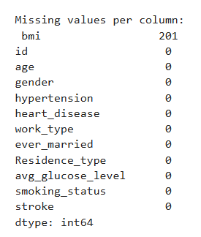
Figure 1.Missing Value

Medical datasets frequently contain missing values due to factors such as incomplete clinical documentation, patient non-disclosure, or measurement constraints. In the present dataset, certain attributes—most notably Body Mass Index (BMI)—include missing entries.
Addressing missing data requires a careful balance between statistical rigor and clinical plausibility. Naïvely removing records with missing values can result in substantial information loss and may introduce bias, particularly when the missingness mechanism is not completely random. Consequently, appropriate imputation strategies are employed during the preprocessing stage to preserve the integrity of the dataset while minimizing distortion of the underlying data distribution. These strategies aim to retain clinically meaningful information and support robust model learning.

3.7 Ethical Considerations in Medical Data Usage
The application of medical data for predictive modeling introduces significant ethical considerations. Even when datasets are fully anonymized, there remains a responsibility to ensure patient privacy, fairness, and responsible interpretation of model outputs.
Predictive models developed in this study are not intended to replace clinical expertise or medical decision-making. Rather, they are designed to function as clinical decision support tools, assisting healthcare professionals in risk assessment and prioritization. Furthermore, biases inherent in medical datasets—such as the underrepresentation of certain demographic or socioeconomic groups—may lead to disparities in predictive performance across populations.
Ethical deployment of stroke prediction systems therefore necessitates transparency in model design, rigorous validation across diverse patient cohorts, and clear communication of model limitations. These measures are essential to promote trust, equity, and safe integration of artificial intelligence systems into clinical practice.

3.8 Image Dataset Description(CT Scan Data)

3.8.1 Image Dataset Overview and Source
The image dataset used in this study consists of brain Computed Tomography (CT) scans collected from a publicly available dataset on the Kaggle platform. CT imaging is widely utilized in clinical practice for the early diagnosis of stroke due to its fast acquisition time, availability, and effectiveness in detecting acute cerebral abnormalities.
The dataset contains a total of 2,501 CT images, categorized into two classes:
• Stroke: 950 CT images representing patients diagnosed with stroke
• Normal: 1,551 CT images representing healthy brain scans
The images are labeled at the image level and are intended for binary classification, where the objective is to distinguish between normal brain scans and scans exhibiting stroke-related abnormalities.
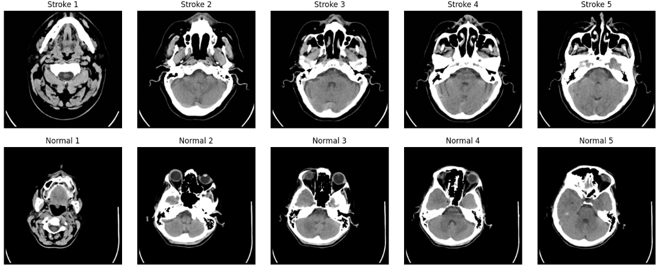
Figure 2.Dataset image

Figure 3.Dataset RAW

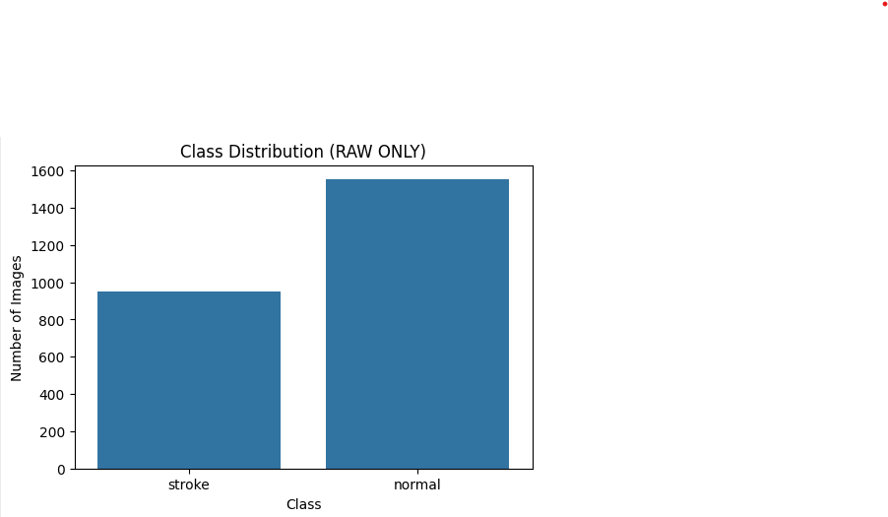

3.8.2 Image Data Characteristics

All images in the dataset are brain CT scans acquired in axial view, which is the standard orientation used in clinical stroke diagnosis. The dataset exhibits natural variability in terms of image quality, contrast, intensity distribution, and anatomical appearance.

Such variability reflects real-world clinical conditions and increases the robustness of the trained model. However, it also introduces challenges for automated image analysis, as stroke lesions may appear with subtle intensity differences and irregular shapes that are difficult to detect using traditional image processing techniques.

Figure 4.BLUR BEFOR

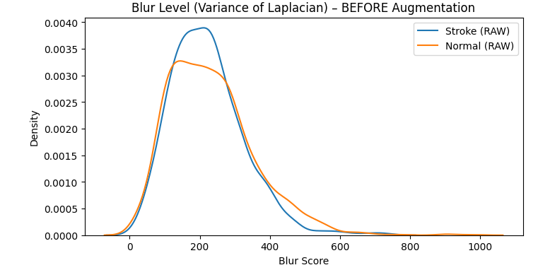

3.8.3 Image Preprocessing

Before training and inference, the CT images undergo a standardized preprocessing pipeline to ensure compatibility with deep learning models, particularly Vision Transformer–based architectures.

The preprocessing steps include:
• Conversion of grayscale CT images to RGB format
• Resizing all images to a fixed resolution of 224 × 224 pixels
• Normalization using ImageNet mean and standard deviation
• Conversion of images into tensor format for PyTorch-based inference

These steps ensure consistent input representation and allow the use of pretrained models through transfer learning, which improves performance and reduces training time when working with limited medical image datasets.

3.8.4 Class Distribution and Imbalance

The image dataset exhibits a moderate class imbalance, with a higher number of normal images compared to stroke images. This imbalance reflects real clinical prevalence but may bias the model toward the majority class if not properly addressed.

To reduce the impact of class imbalance, data augmentation techniques are applied during training, including random transformations such as rotation and flipping. These techniques increase data diversity and help the model learn more generalized stroke-related patterns without altering the clinical meaning of the images.

From a medical perspective, minimizing false negatives (missed stroke cases) is more critical than maximizing overall accuracy, as undetected stroke cases may lead to delayed or inadequate medical intervention.
Figure 5.Dataset AUG
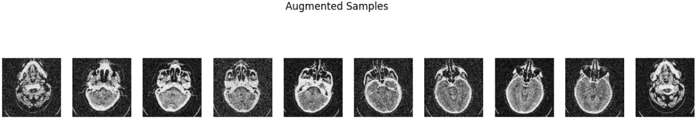
Figure 6.BLUR AFTER

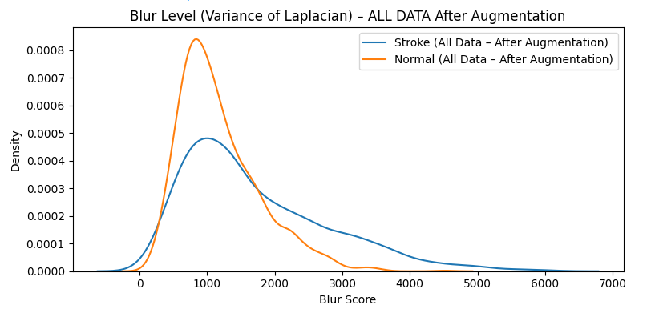

Figure 7 .Dataset ALL RAW-AUG
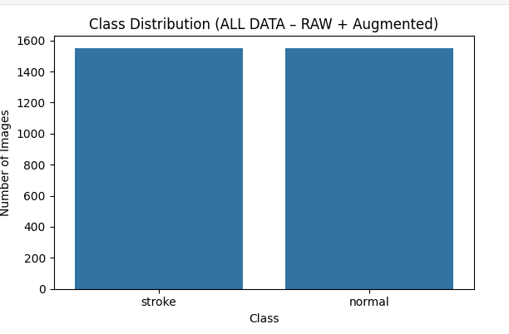

3.8.5 Clinical Relevance of Image-Based Analysis
CT imaging plays a crucial role in the early diagnosis of stroke, particularly in emergency settings. Automated analysis of CT images using deep learning can support clinicians by providing rapid preliminary assessments and highlighting suspicious regions that may require closer examination.
In this project, the image-based model complements the clinical data–based prediction system. Together, they form a multimodal framework that enhances robustness, interpretability, and clinical relevance, while maintaining the role of artificial intelligence as a decision-support tool rather than a replacement for medical expertise.

Chapter 4 Implementation

4.1 Introduction
Stroke is one of the leading causes of mortality and long-term disability worldwide. Early identification of individuals at high risk plays a critical role in prevention and timely medical intervention. Recent advancements in artificial intelligence (AI) and machine learning (ML) have enabled the development of predictive systems capable of analyzing complex medical data and medical images with high accuracy.

4.2 System Architecture Overview
The proposed system follows a modular AI architecture, composed of the following layers:
- Data Processing & Model Training Layer
Implemented in the Googel Colab for data cleaning, feature engineering, model training, and evaluation.
- Inference & Explainability Layer
Includes probability estimation, risk classification, and visual explainability using Grad-CAM for image-based predictions.
- User Interface Layer
Implemented using Streamlit to allow real-time interaction, bilingual support (English/Arabic), and visualization of results.
4.2 Dataset Handling and Preprocessing
- The notebook processes a structured medical dataset containing patient attributes such as:
- Demographic features (age, gender, residence type)
- Medical history (hypertension, heart disease)
- Lifestyle factors (smoking status, work type)
- Clinical measurements (BMI, average glucose level)
- Key preprocessing steps include:
- Handling missing BMI values using a binary missing indicator
- Logarithmic transformation of glucose levels to reduce skewness
- Encoding categorical variables in a format compatible with CatBoost
- Feature selection aligned with medical relevance

4.3 Feature Engineering
- The following engineered features are used:
- bmi_missing: Explicit indicator for missing BMI values
- log_glucose: Log-transformed glucose level for numerical stability
- These features improve model robustness and interpretability, especially in real-world clinical settings where incomplete data is common.

4.3 Train–Test Split and Experimental Setup
To evaluate generalization performance, the dataset is divided into training and testing subsets. The training set is used to fit the models, while the test set simulates unseen patient data.
Separating data in this manner prevents information leakage and ensures that performance metrics reflect realistic predictive capability. In medical applications, such separation is critical to avoid overly optimistic results that may not translate to real clinical environments.

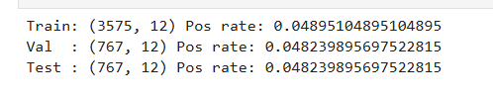
Figure 2.Spliting Data

4.4 Model Selection:

CatBoostClassifier
CatBoost is selected due to:
- Native handling of categorical variables
- Reduced need for extensive preprocessing
- Strong generalization performance on tabular medical data
The model outputs probabilistic predictions, enabling risk stratification rather than binary diagnosis.

5. Image-Based Stroke Risk Classification

Vision Transformer Architecture
The image-based module uses a Vision Transformer (ViT) with a patch-based self-attention mechanism. Unlike CNNs, ViTs capture global spatial relationships, which is particularly beneficial in medical imaging.

Image Preprocessing Pipeline
Uploaded images undergo:
- RGB conversion
- Resizing to 224×224 pixels
- Normalization using ImageNet statistics
- Tensor conversion for PyTorch inference
This ensures compatibility with the trained model.

Prediction and Confidence Estimation
The ViT model produces:
- Softmax probabilities
- Top-k class predictions
- Confidence scores visualized using progress indicators and gauges

Explainable AI Using Grad-CAM
To enhance transparency, Grad-CAM is applied to the ViT model:
- Gradients are extracted from the final transformer layers
- Attention maps are generated and upsampled
- Heatmaps are overlaid on original images
This allows clinicians to visually inspect which regions influenced the model’s decision, increasing trust and accountability.
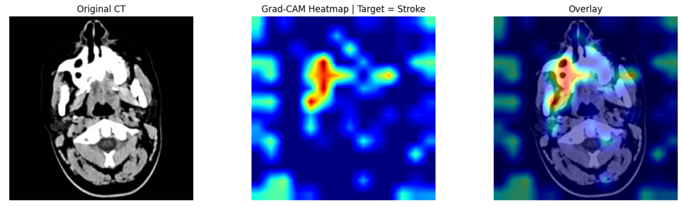
Figure 8.Heat Map

Deployment Using Streamlit and Application Design

The system is deployed using the Streamlit framework, which enables rapid development and deployment of interactive machine learning applications. Streamlit provides a lightweight yet powerful environment that allows seamless integration between trained models and a web-based user interface.
Application Design

The system is deployed using Streamlit, providing:
• Real-time inference for both clinical and image-based inputs.
• A responsive, dashboard-style user interface suitable for clinical and technical users.
• Minimal configuration overhead, allowing the system to be executed locally or deployed on cloud platforms with minimal setup
The application architecture follows a modular design, enabling independent loading and execution of different models while maintaining a unified interface.

Bilingual and Accessibility Features
The application supports:
- English (left-to-right layout)
- Arabic (right-to-left layout)
Language selection dynamically updates all interface elements, including labels, instructions, warnings, and result summaries. Dynamic CSS styling is applied to ensure proper text alignment, layout direction, and readability for both languages. This design enhances accessibility and usability for a broader range of users, particularly in multilingual clinical environments.

Multi-Modal User Interface Design
The application integrates two complementary interaction modes within a single unified interface:
.1Clinical Data Entry Interface
In the clinical mode, users manually input patient-related information through structured form components. The interface is organized into clearly defined sections, including:
- Personal information (e.g., age, gender, residence type).
- Medical history (e.g., hypertension, heart disease).
- Vital signs and lifestyle indicators (e.g., glucose level, BMI, smoking status).
Standardized input controls such as dropdown menus, numeric fields, and checkboxes are used to reduce input errors and enforce valid data ranges. Missing clinical values, such as unknown BMI, are explicitly handled through indicator variables to maintain model robustness and reduce bias.
.

.2Image-Based Analysis Interface
In addition to structured clinical input, the system provides an image-based analysis mode accessible through the same interface. This mode allows users to upload medical images using a secure file uploader component.
Key features of the image-based interface include:
- Immediate visual preview of the uploaded image to ensure correctness before analysis.
- Automated preprocessing and classification using a Vision Transformer (ViT) model.
- Display of top predicted classes with associated probability scores.
- Optional activation of Grad-CAM visual explanations, enabling users to inspect the image regions that contributed most to the model’s decision.
The image-based interface is fully integrated into the same application workflow, allowing seamless switching between clinical and image-based assessment without requiring separate tools or applications.

Visualization and Decision Support
To enhance interpretability and clinical usefulness, the system incorporates multiple visualization components:
- Probability gauges to represent stroke risk or image classification confidence.
- Comparative bar charts that contrast patient-specific values with population averages.
- Progress indicators for ranked prediction outputs in image classification.
- Context-aware medical warnings, triggered automatically for known risk factors such as hypertension, cardiovascular disease, or advanced age.
These visualization mechanisms transform raw probabilistic outputs into actionable and intuitive clinical insights, supporting informed decision-making rather than presenting opaque model predictions.
.

. Performance and Reliability Considerations
Several design choices were implemented to ensure reliable and efficient deployment:
- Model caching is used to minimize inference latency and avoid redundant model loading.
- Graceful error handling detects missing model files, incompatible checkpoints, or invalid inputs and provides informative feedback to the user.
- CPU/GPU compatibility enables flexible deployment across heterogeneous hardware environments.
- A modular architecture supports future extensions, such as additional models, new input modalities, or enhanced explainability methods.

Ethical and Clinical Implications
The system is designed as a clinical decision support tool, not a diagnostic authority. Emphasis is placed on:
- Probability-based outputs
- Explainability
- Bias mitigation through missing-data indicators
- Transparency in model behavior


Figure 9.Application Interface

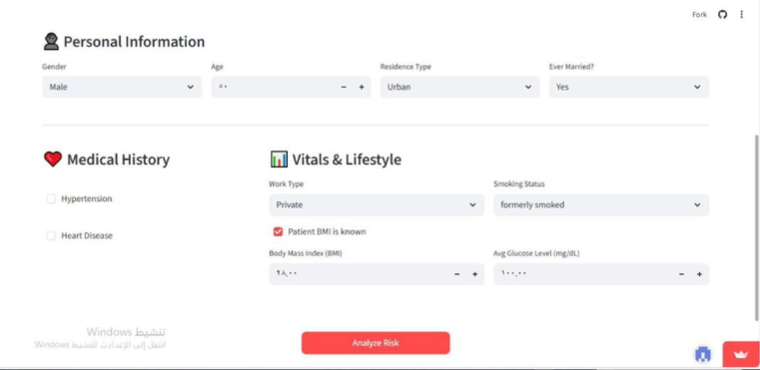
Figure 5..Application Interface


Figure6..Application Interface

10. Conclusion
This paper presents a comprehensive, explainable, and deployable AI system for stroke risk prediction. By integrating structured clinical data, medical imaging, explainable AI techniques, and a bilingual user interface, the system addresses key challenges in real-world medical AI deployment. The proposed approach demonstrates how advanced machine learning and deep learning models can be responsibly applied to healthcare while maintaining interpretability and usability.

Chapter 5 Result

5.1 Evaluation Metrics for Imbalanced Medical Data
In medical prediction tasks such as stroke risk assessment, model evaluation must extend beyond simple accuracy. Due to the inherent class imbalance in the dataset, accuracy alone can be misleading and clinically unsafe.
A model that predicts all patients as non-stroke could achieve high accuracy while completely failing to identify individuals at risk. Therefore, this study employs multiple evaluation metrics to provide a comprehensive assessment of model performance:
Accuracy: Overall proportion of correct predictions
Precision: Proportion of predicted stroke cases that are true strokes
Recall (Sensitivity): Proportion of actual stroke cases correctly identified
F1-score: Harmonic mean of precision and recall
Confusion Matrix: Detailed breakdown of prediction outcomes
Among these metrics, recall is of particular importance, as false negatives represent patients whose stroke risk is not identified, potentially leading to preventable adverse outcomes.

5.2 Confusion Matrix Interpretation Using Synthetic Data
The confusion matrix offers a comprehensive overview of the model’s predictive performance and consists of four fundamental components:
True Positives (TP): Synthetic high-risk instances correctly classified by the model
True Negatives (TN): Synthetic low-risk instances correctly classified as non-risk
False Positives (FP): Synthetic low-risk instances incorrectly classified as high risk
False Negatives (FN): Synthetic high-risk instances incorrectly classified as low risk
Within the context of synthetic data analysis, false negatives represent the most critical type of error, as they indicate simulated high-risk cases that the model fails to identify. Such errors reduce the model’s ability to capture important risk patterns embedded in the generated dataset. Conversely, false positives, although they negatively impact precision, primarily lead to an increase in incorrectly flagged instances without introducing direct adverse consequences.
Accordingly, in risk-sensitive modeling scenarios using synthetic data, models that emphasize higher recall—potentially at the expense of moderate precision—are generally preferred, as they enhance the detection of high-risk patterns and improve overall model robustness.
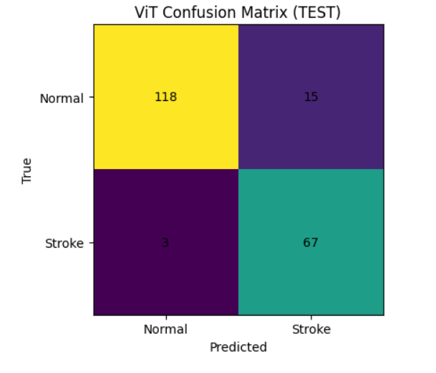
Figure 7.Confusion Matrix
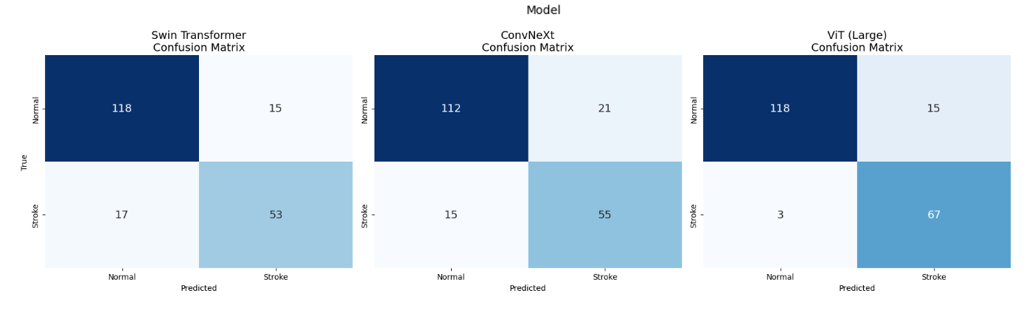
Figure 8.Compare Result CM

Architectures:
Swin Transformer, ConvNeXt and ViT Large pretrained on ImageNet.
Training: finetuned for 10 epochs with data augmentation; early stopping to prevent overfitting.
Results: ViT achieves the highest accuracy (~91%) and ROC-AUC (~0.98).
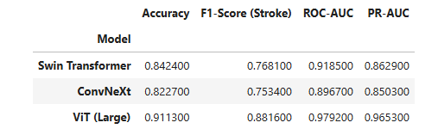

5.3 Logistic Regression Results
Logistic regression serves as a baseline model due to its interpretability and widespread use in medical research.
The model demonstrates moderate accuracy and reasonable precision, indicating its ability to correctly classify many non-stroke cases. However, recall for the stroke class is limited, reflecting difficulty in capturing complex non-linear interactions among risk factors.
From a medical standpoint, logistic regression effectively models well-known linear risk contributors such as age and hypertension but struggles with subtle interactions between lifestyle and metabolic features. While its interpretability is valuable, its predictive limitations reduce its suitability as a standalone screening tool.
Importantly, no model achieves perfect performance. This underscores the necessity of integrating machine learning predictions with clinical expertise rather than relying solely on automated system

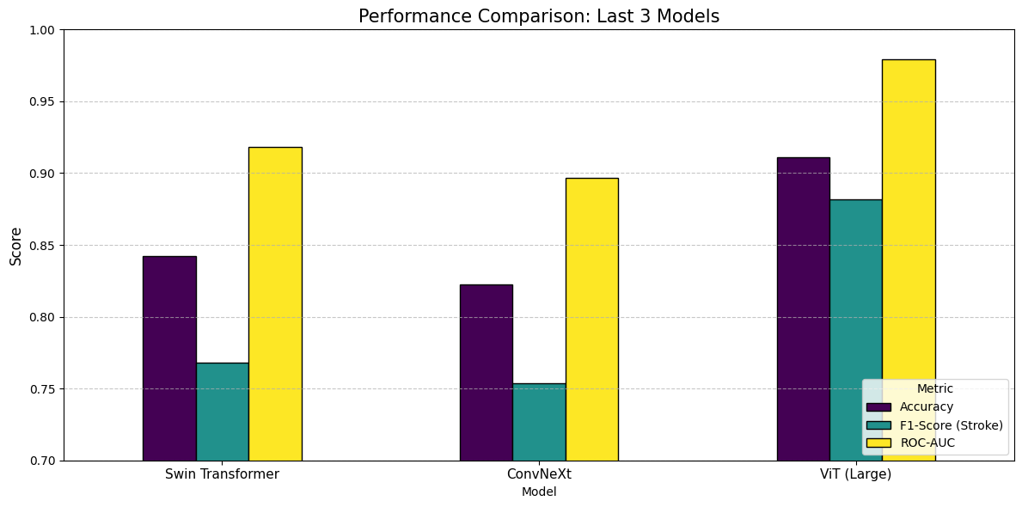
Figure 9.Performance Comparison

Training Loss per Epoch
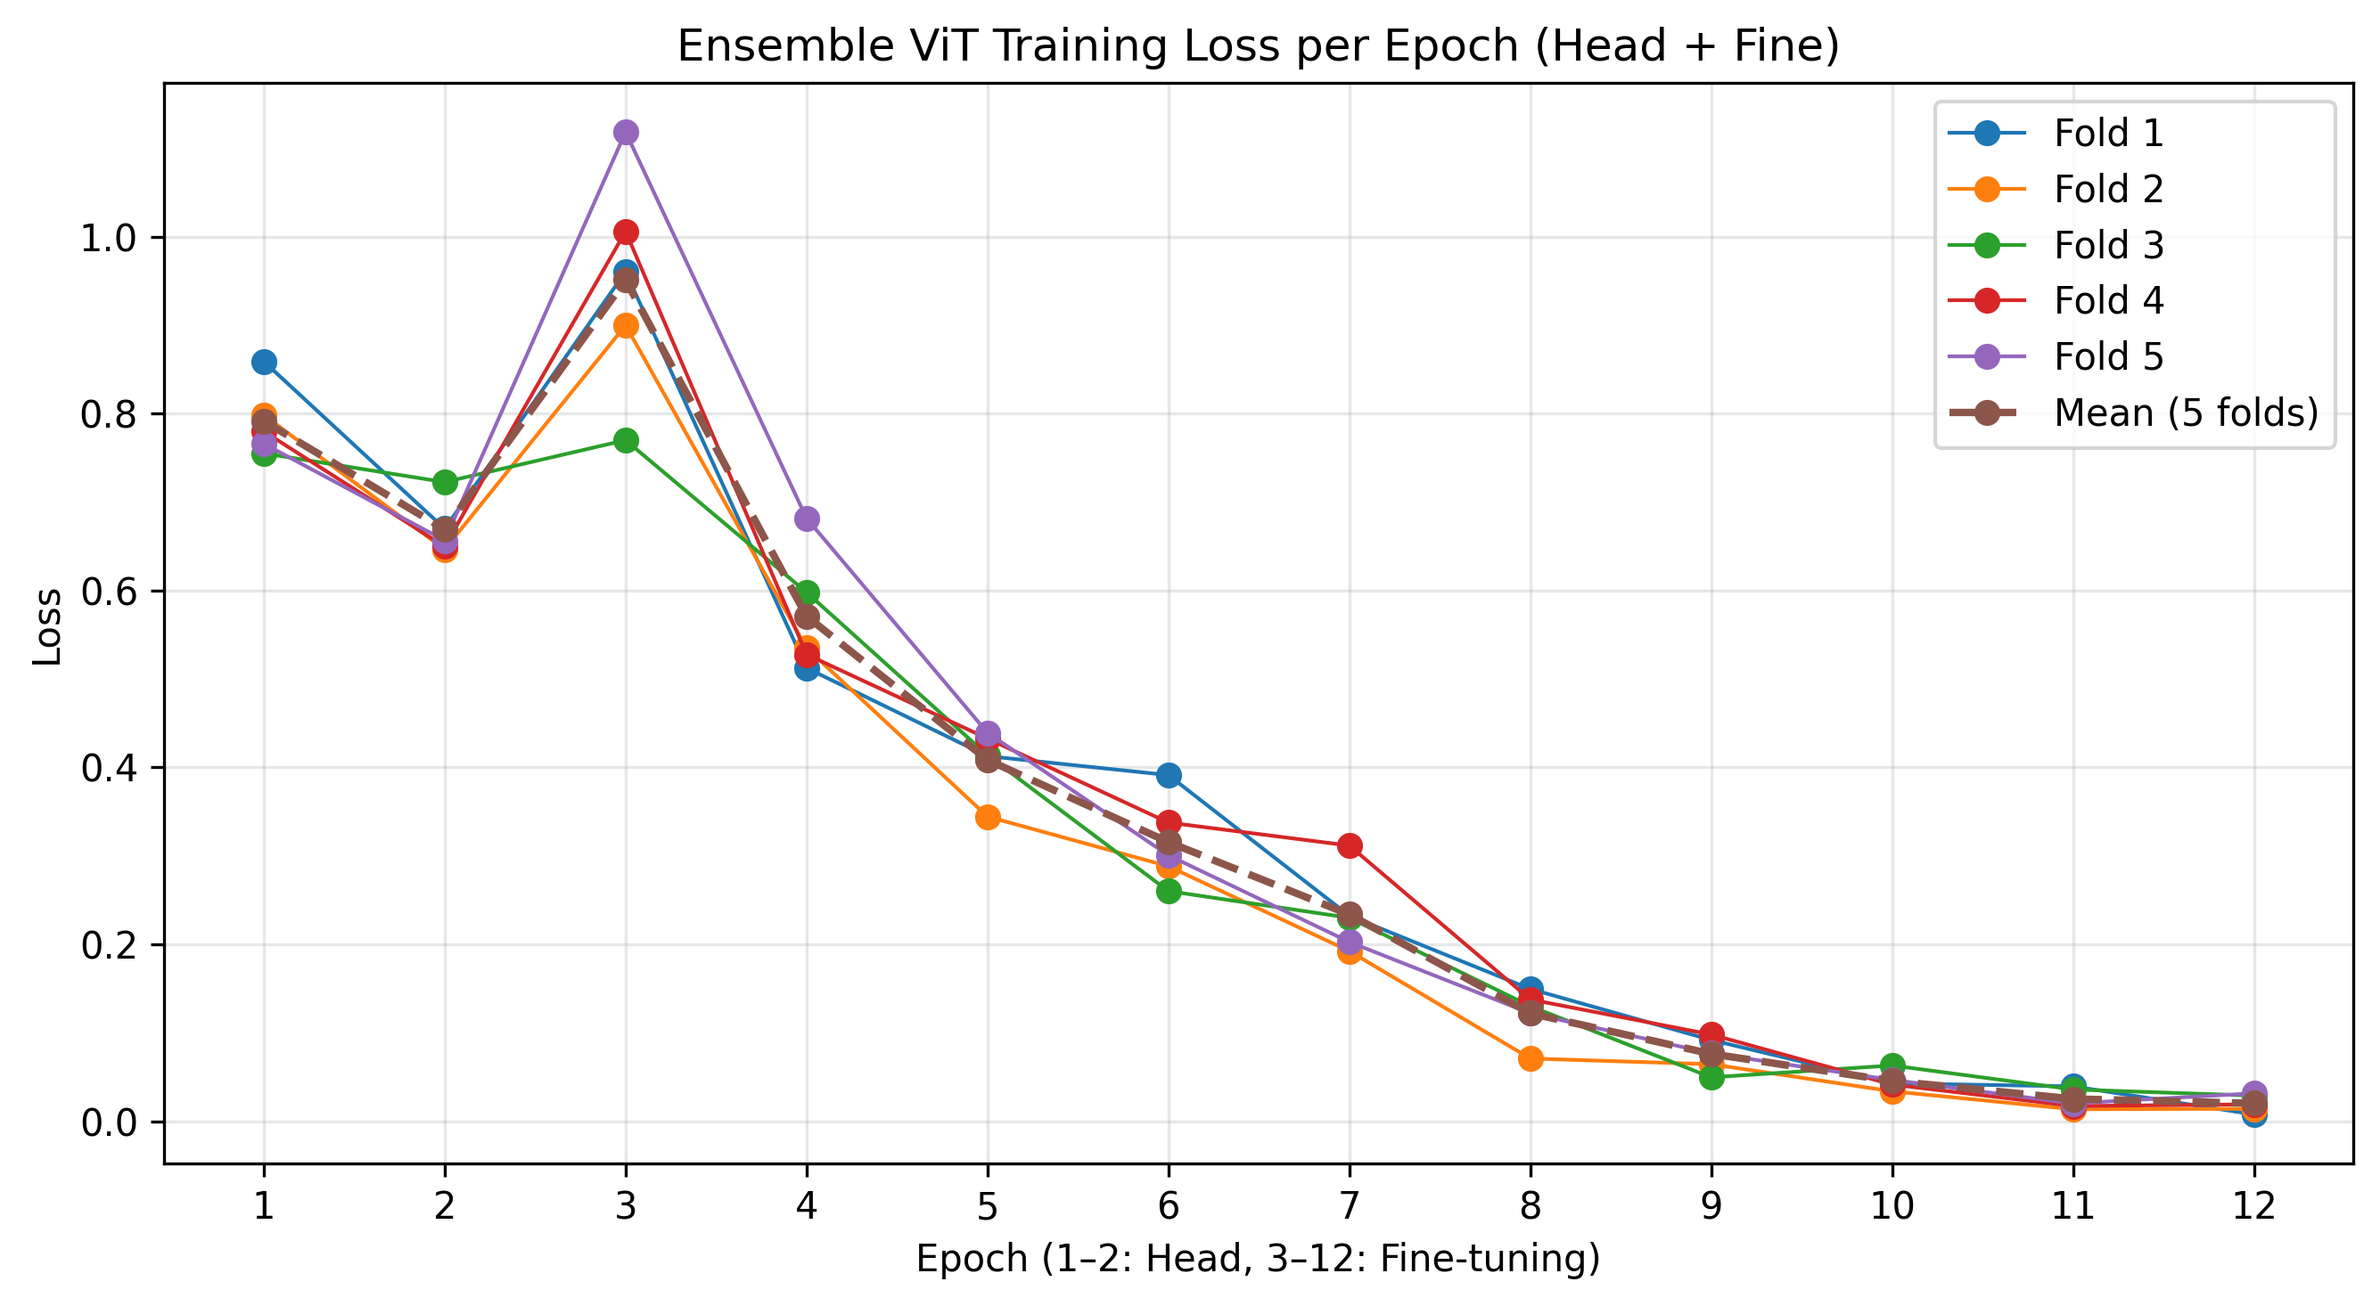
Figure 10.Ensemble Vit loss Plot

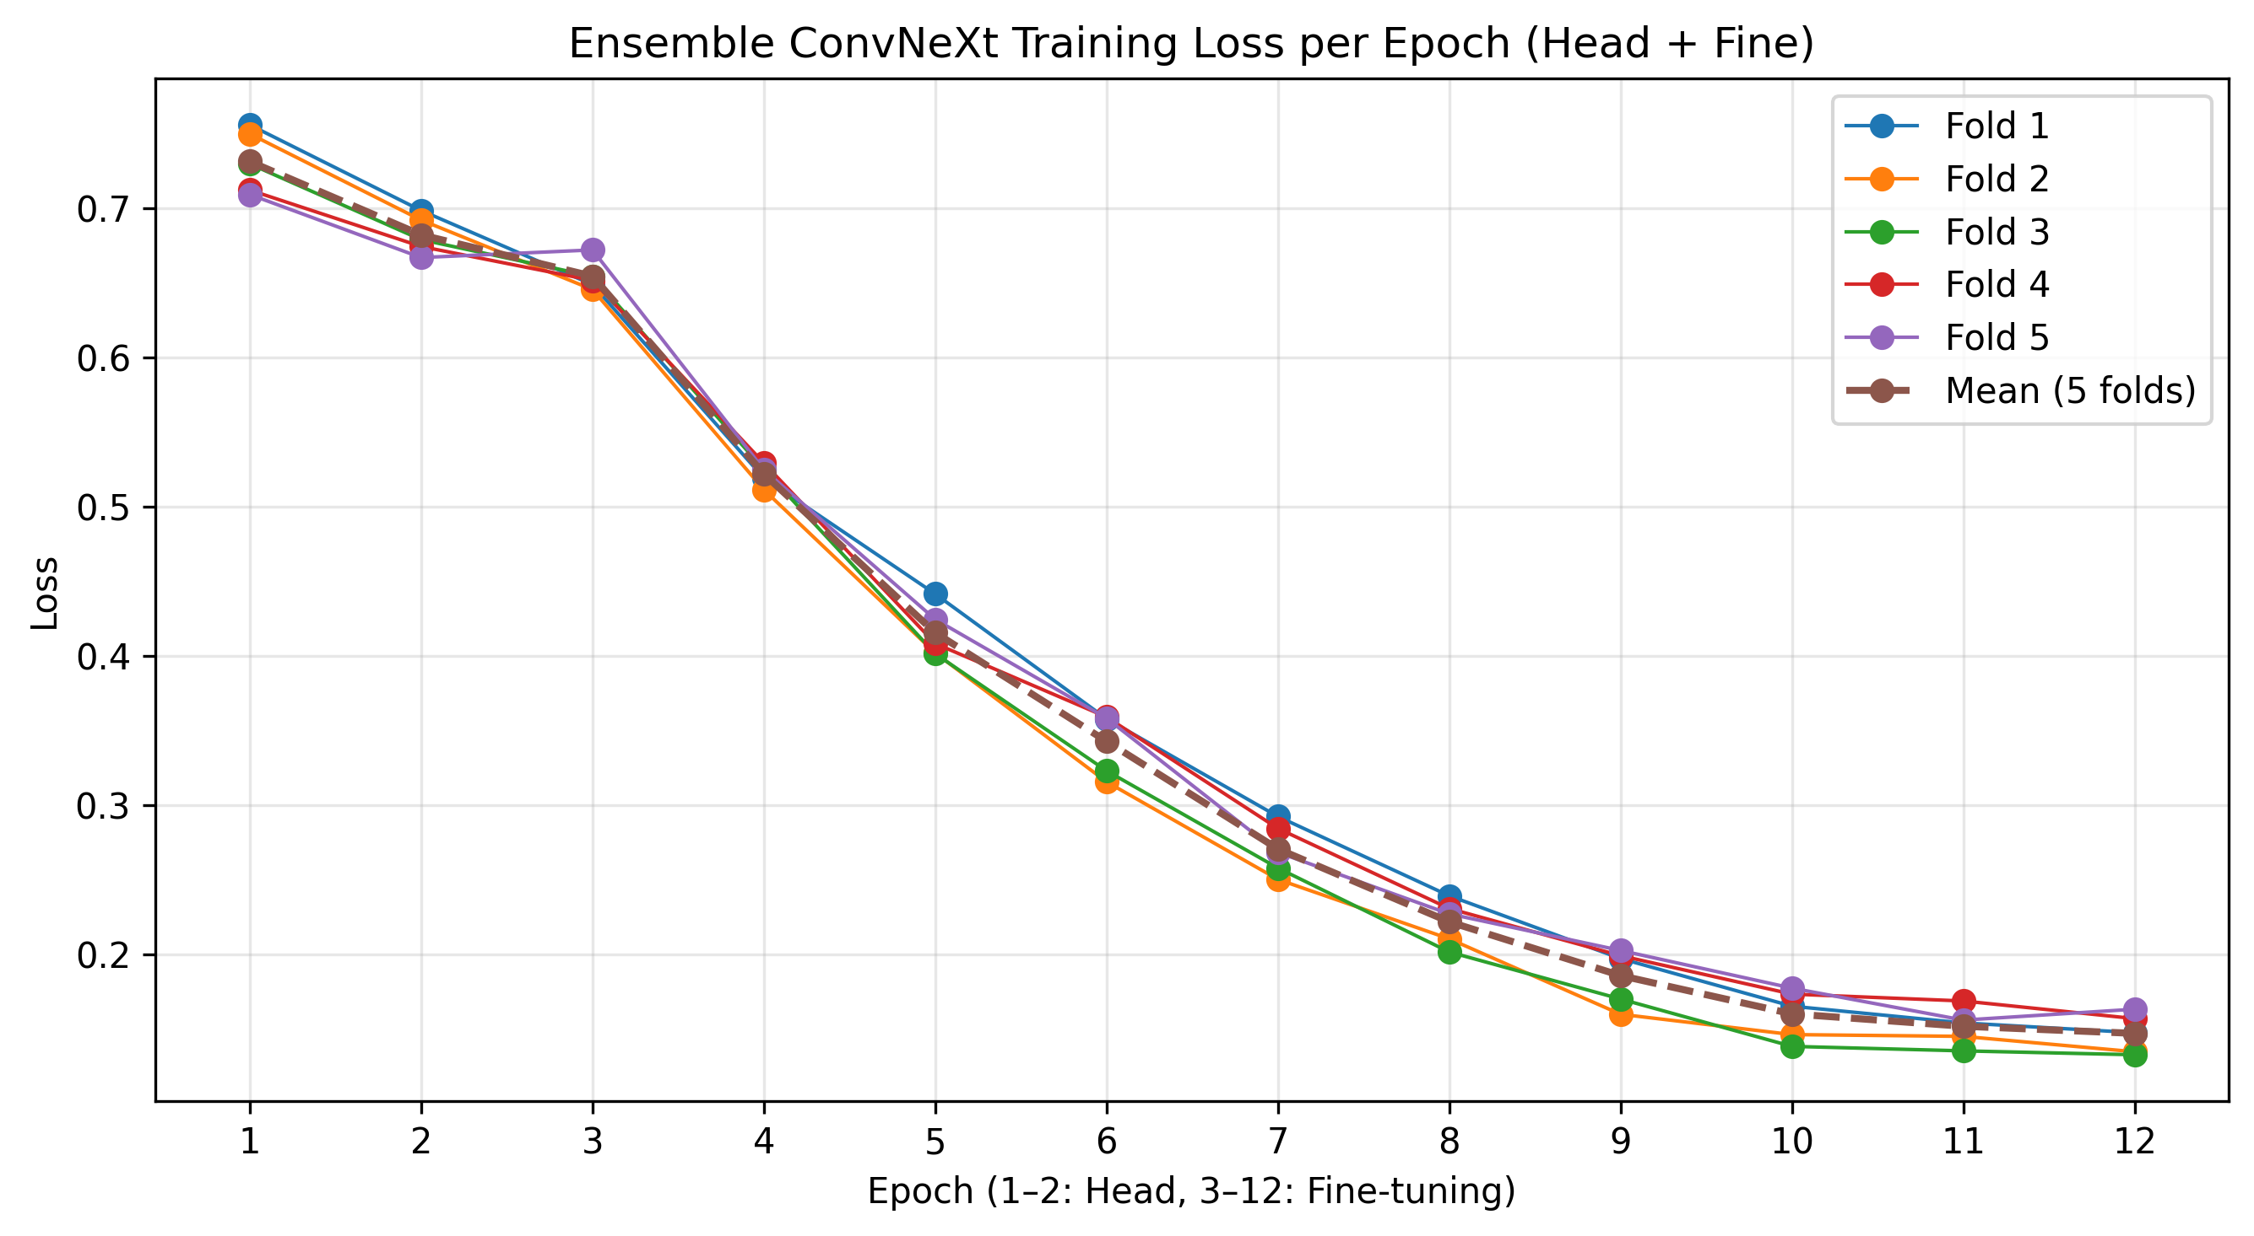
Figure 11.Ensemeble ConnVeXt Loss plot

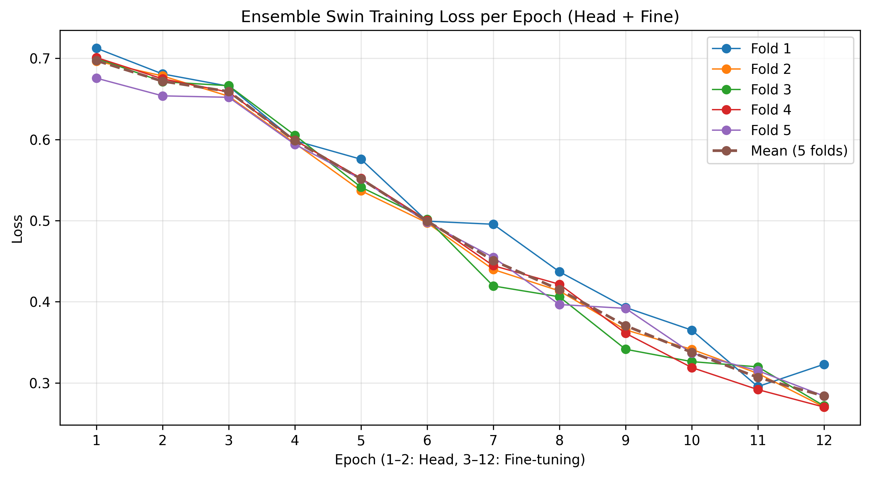
Figure 12.Ensemeble swint Loss plot



Figure 13.interface image
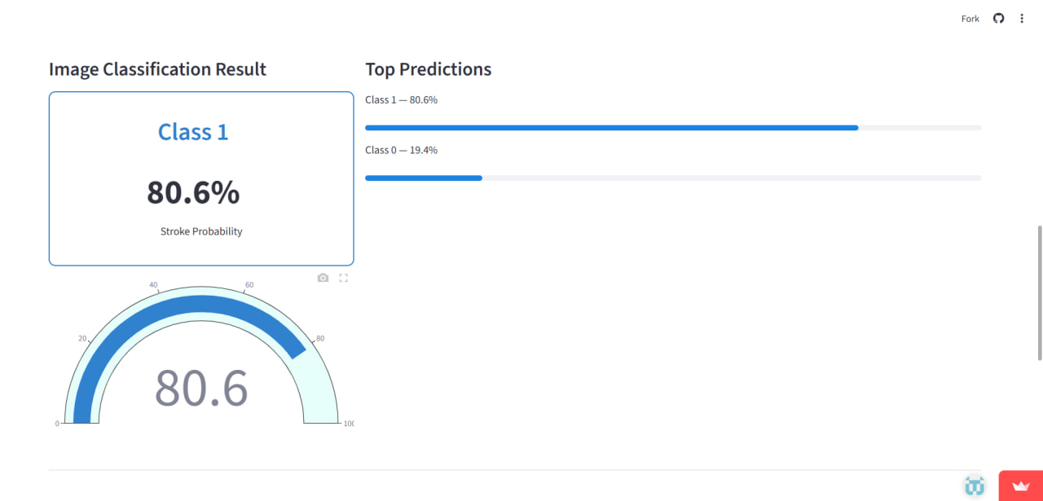

Figure 14.interface image result

5.4 Results Overview on Clinical Textual Data
This section presents the experimental results obtained from analyzing clinical textual data using the proposed machine learning model. The dataset consists of structured textual records representing patient-related information, which were processed and transformed into numerical representations suitable for model training and evaluation. The primary objective of this analysis is to assess the model’s ability to identify relevant risk-related patterns within clinical text data, based on predefined classification criteria.
The model’s performance is evaluated using standard classification metrics derived from the confusion matrix, enabling a detailed examination of prediction outcomes across different classes. The following results highlight the strengths and limitations of the model when applied to clinical textual data and provide insights into its effectiveness in capturing meaningful patterns relevant to the study objectives.

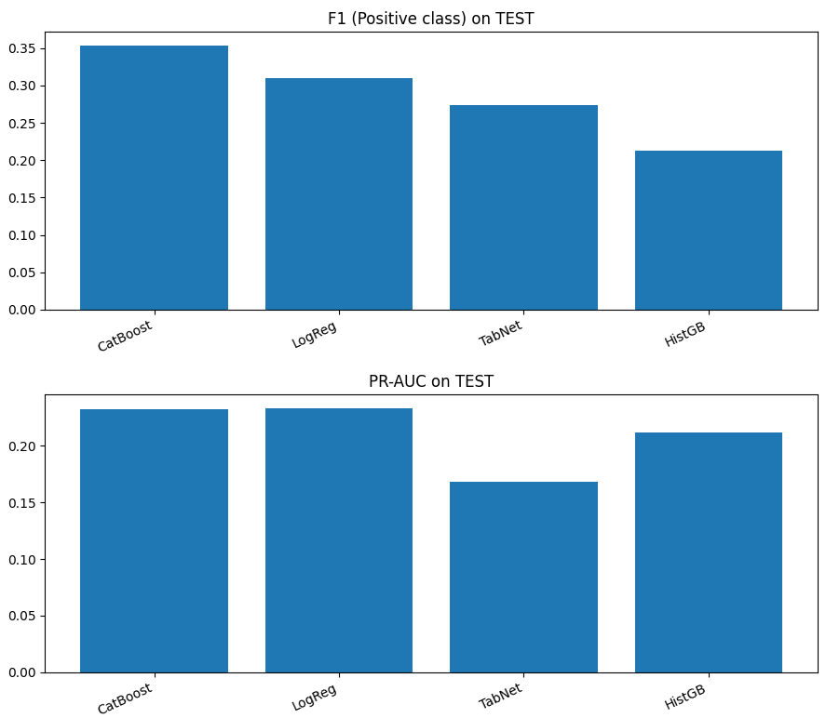
Figure 15. Performance Comparison

Architectures:
CatBoost, Logistic Regression (LogReg), TabNet, and Histogram-based Gradient Boosting (HistGB) applied to tabular data.
Training:All models were trained using standardized preprocessing procedures. Model-specific hyperparameters were tuned empirically, and early stopping was applied where supported to mitigate overfitting and improve generalization performance.
Results:CatBoost and Logistic Regression achieved the strongest overall performance, with CatBoost reaching an accuracy of approximately 66% and a ROC AUC of 0.83, while Logistic Regression obtained the highest accuracy at approximately 76% with a comparable ROC AUC of 0.83. TabNet achieved the highest accuracy (~87%) but showed lower recall for the positive class, indicating limited sensitivity to minority-class instances. HistGB demonstrated moderate discrimination capability (ROC AUC ≈ 0.82) but underperformed in recall. Overall, CatBoost provided the most balanced performance across accuracy, recall, and F1-score for the positive class.

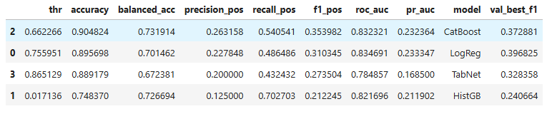

5.5 Confusion Matrix Interpretation in Clinical Context
The confusion matrix provides a detailed representation of model predictions and consists of four components:
True Positives (TP): Correctly identified stroke cases
True Negatives (TN): Correctly identified non-stroke cases
False Positives (FP): Non-stroke cases incorrectly predicted as stroke
False Negatives (FN): Stroke cases incorrectly predicted as non-stroke
From a clinical perspective, false negatives are the most dangerous outcome, as they may result in missed opportunities for preventive intervention. False positives, while undesirable, typically lead to further screening rather than direct harm.
Therefore, models that achieve higher recall at the cost of moderate precision may be preferable in stroke risk prediction settings
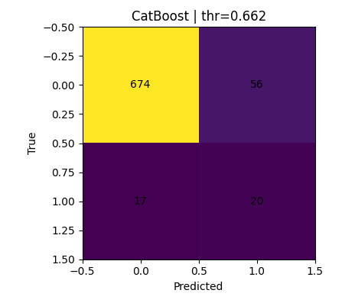
Figure 16.Compare Result CM

ROC & PR Curves

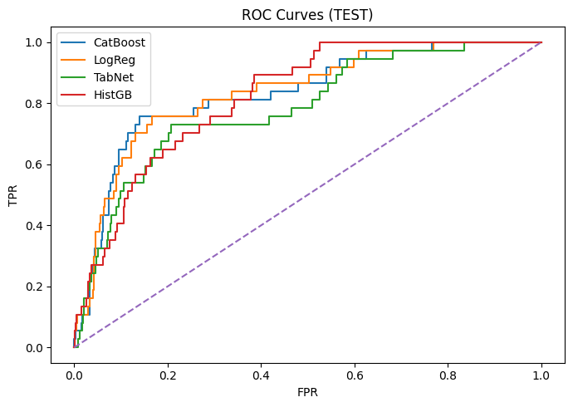
Figure 17..ROC plot

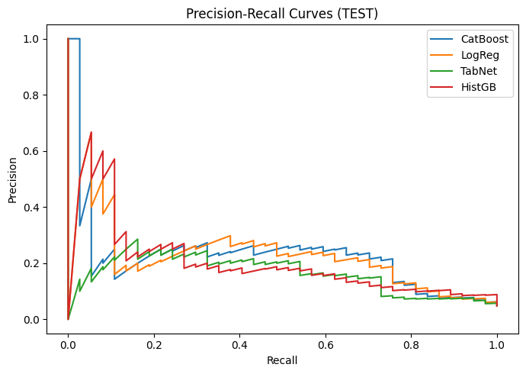
Figure 18..precision-Recall plot


Figure 19. Analyze Risk text

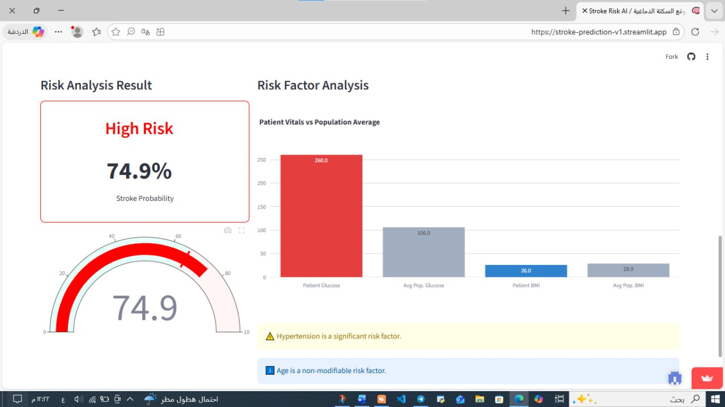
Figure 20. Analyze Risk text result

Figure 21. Analyze Risk text

Figure 22. Analyze Risk text result
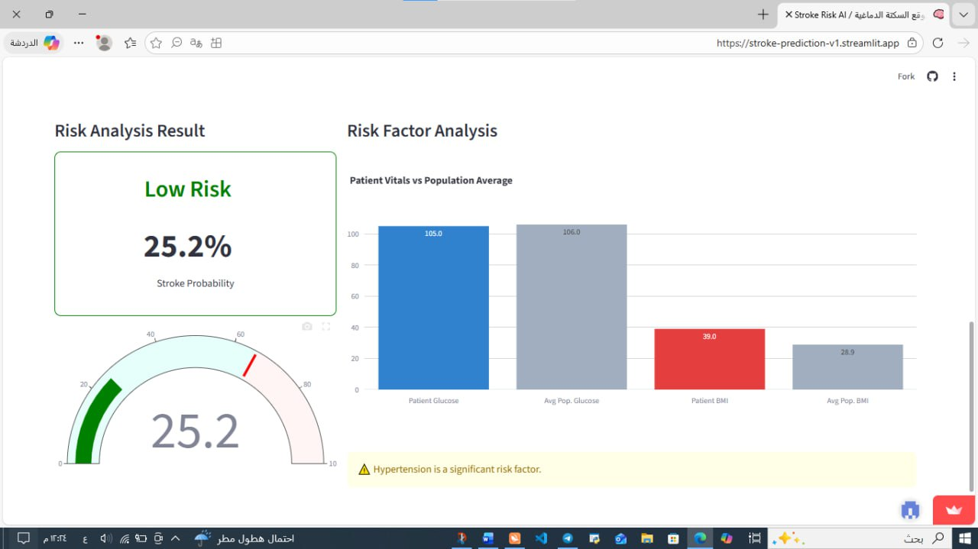

5.6 Limitations of Results
Despite encouraging results, several limitations must be acknowledged. The dataset represents a specific population and may not generalize to all demographic groups. Additionally, stroke prevalence in the dataset is relatively low, which constrains model learning and evaluation.
Moreover, retrospective prediction does not guarantee prospective accuracy. Clinical validation using real-time patient data would be required before deployment in healthcare settings.

Chapter 6 Conclusion

6.1 Conclusion
- This study investigated the application of machine learning techniques for predicting stroke risk using a structured clinical dataset. Stroke remains one of the leading causes of mortality and long-term disability worldwide, making early identification of high-risk individuals a critical component of preventive healthcare. By integrating domain-specific medical knowledge with data-driven modeling approaches, this work demonstrates the potential of machine learning systems to support clinical decision-making processes.
- Three supervised learning algorithms—Logistic Regression, K-Nearest Neighbors (KNN), and Random Forest—were designed, implemented, and evaluated within a unified and consistent machine learning pipeline. Each model exhibited distinct strengths and limitations. Logistic Regression offered high interpretability and transparency but was limited in its ability to capture complex, non-linear feature interactions. KNN demonstrated improved sensitivity to stroke cases but suffered from reduced robustness and lower precision. In contrast, the Random Forest model achieved the strongest overall performance by effectively modeling non-linear relationships and maintaining a balance between recall and precision.
- The results emphasize that no single evaluation metric is sufficient for assessing medical prediction models. In the context of stroke risk prediction, recall and F1-score are more clinically meaningful than accuracy alone, as failing to identify high-risk individuals may result in preventable adverse outcomes. These findings highlight the importance of aligning model evaluation strategies with real-world clinical priorities.
- Overall, this study demonstrates that machine learning models, when carefully designed, evaluated, and interpreted, can enhance stroke risk assessment. Nevertheless, such models should be regarded as decision-support tools rather than replacements for clinical expertise.

6.2 Study Limitations
- Despite the promising findings, several limitations of this study must be acknowledged.
- First, the dataset employed represents a limited population and may not fully capture the diversity of global stroke risk profiles. Variations in ethnicity, socioeconomic status, healthcare access, and genetic predisposition may affect the generalizability of the proposed models.
- Second, the dataset exhibits significant class imbalance, reflecting the real-world prevalence of stroke but posing challenges for model training and evaluation. Although appropriate performance metrics were adopted, the relatively small number of positive stroke cases limits the statistical power of model comparisons.
- Third, the prediction task is based on retrospective data. While historical stroke occurrence provides valuable insights into associated risk factors, it does not guarantee prospective predictive accuracy. Real-time clinical validation is therefore necessary before deployment in healthcare settings.
- Finally, several features rely on self-reported information, which may introduce reporting bias. The inclusion of clinically measured variables collected under standardized conditions could further enhance predictive reliability.

6.3 Ethical Considerations
- The application of machine learning techniques in healthcare raises important ethical considerations. Although the dataset used in this study is anonymized, responsible data handling, analysis, and interpretation remain essential.
- Predictive models may unintentionally reflect biases present in the underlying data, potentially resulting in unequal predictive performance across demographic groups. If unaddressed, such biases could exacerbate existing healthcare disparities. Consequently, transparency, fairness assessment, and validation across diverse populations are critical prerequisites for clinical adoption.
- Moreover, stroke prediction models should not be used to make autonomous medical decisions. Ethical deployment requires that model outputs are interpreted by qualified healthcare professionals who consider the broader clinical context. Clear communication of model capabilities and limitations is necessary to prevent overreliance on algorithmic predictions.

6.4 Future Work
- Several directions exist for extending this research.
- Future studies could incorporate additional clinical variables, such as blood pressure measurements, cholesterol levels, and genetic markers, to improve predictive performance. The integration of temporal and longitudinal data may enable dynamic risk modeling rather than static classification.
- Advanced machine learning approaches, including gradient boosting methods, neural networks, and deep learning architectures, could further enhance predictive accuracy, particularly when applied to larger and more diverse datasets. However, such approaches must be carefully evaluated to balance performance gains with interpretability.
- Finally, prospective clinical validation using real-world patient data is essential to assess practical applicability. Integrating machine learning-based risk predictions into clinical workflows as decision-support systems represents a promising pathway toward improving stroke prevention and early intervention strategies.

References

[1] World Health Organization, Stroke, Cerebrovascular Accident, WHO Fact Sheets, Geneva, Switzerland, 2023.
[2] V. L. Feigin et al., “Global burden of stroke,” The Lancet Neurology, vol. 18, no. 5, pp. 439–458, 2019.
[3] S. Mendis, P. Puska, and B. Norrving, Global Atlas on Cardiovascular Disease Prevention and Control, World Health Organization, Geneva, Switzerland, 2011.
[4] A. D. Lopez et al., “Global and regional burden of disease,” The Lancet, vol. 380, no. 9859, pp. 2095–2128, 2012.
[5] T. Hastie, R. Tibshirani, and J. Friedman, The Elements of Statistical Learning, 2nd ed., New York, NY, USA: Springer, 2009.
[6] C. M. Bishop, Pattern Recognition and Machine Learning, New York, NY, USA: Springer, 2006.
[7] L. Breiman, “Random forests,” Machine Learning, vol. 45, no. 1, pp. 5–32, 2001.
[8] D. W. Hosmer, S. Lemeshow, and R. X. Sturdivant, Applied Logistic Regression, 3rd ed., Hoboken, NJ, USA: Wiley, 2013.
[9] J. Han, M. Kamber, and J. Pei, Data Mining: Concepts and Techniques, 3rd ed., Waltham, MA, USA: Morgan Kaufmann, 2011.
[10] F. Pedregosa et al., “Scikit-learn: Machine learning in Python,” Journal of Machine Learning Research, vol. 12, pp. 2825–2830, 2011.
[11] K. H. Zou et al., “Statistical validation of predictive models,” Academic Radiology, vol. 11, no. 7, pp. 831–844, 2004.
[12] S. Verma and J. Rubin, “Fairness definitions explained,” in Proc. IEEE/ACM Int. Workshop Software Fairness, 2018, pp. 1–

